Engine Test Data Acquisition

Abstract

This report outlines the development of a high-precision, high-frequency data acquisition system designed for engine firing tests. Beginning with initial design concepts, it details the iterative process undertaken by the Propulsion Team to create a robust thrust force logger, capturing key steps from prototype stages to refined system implementations. The report also covers post-processing methodologies, ensuring accurate analysis for both completed and upcoming engine tests.

Technical Challenge Description

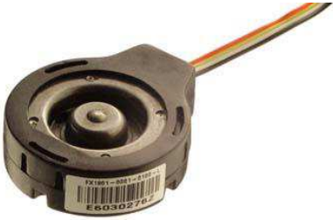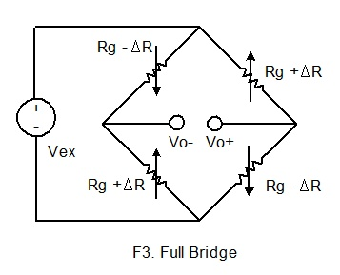Load cells are sensors that convert applied force into an electrical signal, commonly using strain gauges, special resistors that deform under load, changing their electrical resistance. These changes are measured via a Wheatstone bridge circuit, producing a small voltage difference directly proportional to the force. Since this output difference (Vo+- Vo-) is only a few millivolts, signal amplification is essential for accurate recording with a standard Arduino or similar microcontroller. By applying known weights, the voltage difference can be correlated with the applied force, allowing the determination of a precise conversion factor.  
Additionally, the engine’s short burn time (expected to be around 1.5 seconds) necessitates a high sampling frequency to accurately capture the thrust curve.

Compression Load Cell used

Wheatstone bridge

First Iteration

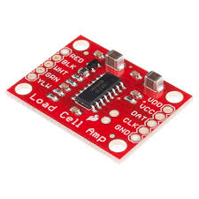Due to limited experience with differential amplifiers, the initial design incorporated the pre-built SparkFun Load Cell Amplifier. This digital module connects directly to the sensor, amplifies its signal with an adjustable gain, converts the analog signal to digital, and transmits it to the microprocessor via the I2C protocol. This simple design revealed several limitations during the first three firing tests. Since the amplifier outputs data in digital format, the sampling rate is restricted by the amplifier’s ADC (analog-to-digital converter) clock, which only allows for a few reads per second. Additionally, the limited selection of gain factors constrains the voltage range, resulting in reduced thrust’s data quality and range. The amplifier's low-quality ADC further compounds this issue, as the available low gains produce unreliable data at lower voltages, capturing meaningful samples only at the peak of the thrust curve. Moreover, due to the relatively light calibration weights used to find the conversion factor from voltage to force, these lower gains were effectively useless for accurate measurements.

SparkFun Load Cell Amplifier

During the initial three engine burns, these issues resulted in three similar, square-shaped thrust curves with high discretization. However, the total impulse measured was quite promising, reaching 130 N·s with the higher amplifier range.

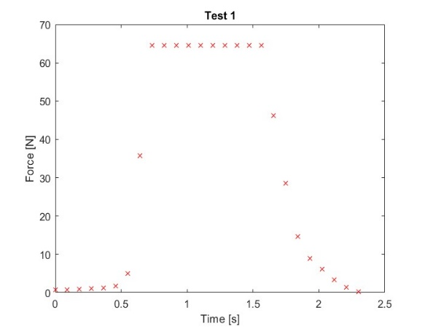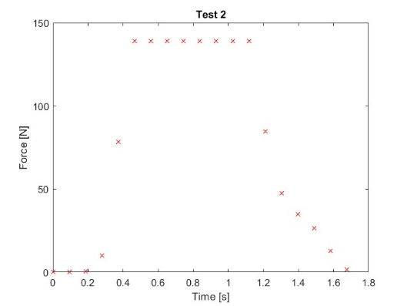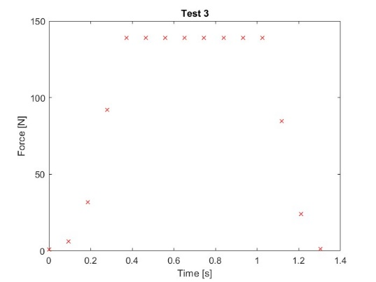

Second Iteration

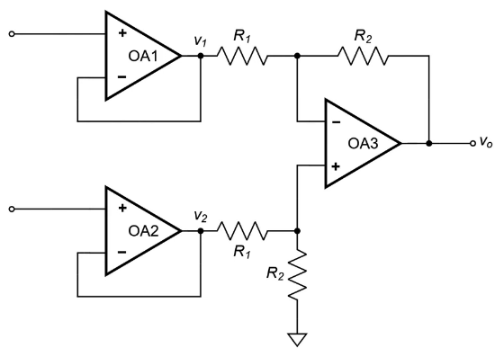In light of these issues, we decided to design the amplifier and sampling circuit from scratch. Drawing on the theory learned in the electronics course, we initially attempted to implement a simple differential amplifier. After adjusting the resistance values to achieve the desired gain factor, we began testing the system. However, our lack of familiarity with low-voltage, high-precision instrumentation amplifiers led to consistency issues caused by low impedance in the system. To address this, we successfully added a voltage follower before each voltage input, significantly increasing the impedance. Additionally, after understanding the difference between common-mode gain (Acm) and differential gain (Ad), we simplified the equations as follows.

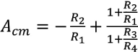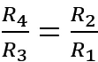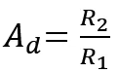

First configuration

Second configuration

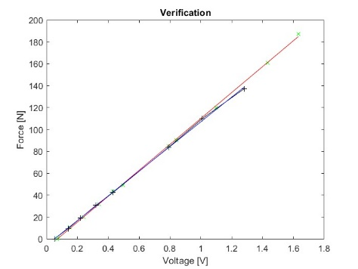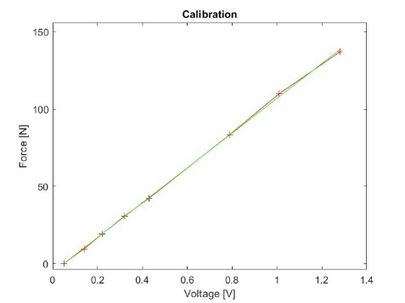To maximize accuracy, we set up a separate scale with increased calibration weights to refine the conversion factors for higher thrust forces, validating its accuracy both in the garage and on the test stand.

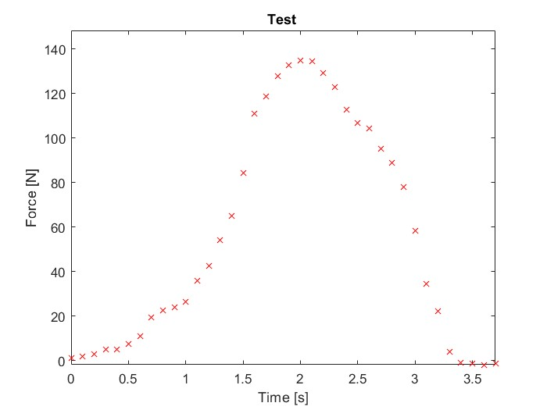This setup proved highly effective, delivering a precise and responsive amplifier that could be easily adjusted to our desired differential gain by switching a few resistors. Leveraging the fully analog system, we utilized the high sampling rate and clock capabilities of our Teensy microcontroller. In the first test, we deliberately limited the sampling frequency to enhance accuracy, yielding an impressive total impulse of 211 N·s. In the second test, we aimed to maximize the sampling rate, but the computer's data logger couldn’t handle the data load (~300,000 samples per second), resulting in a crash before the full curve could be recorded.

Third Iteration

For the third test, the Teensy microcontroller was reassigned to avionics and electronics systems, necessitating a switch to an ESP32. This substitution unexpectedly compromised system functionality: the ESP32’s lower-quality ADC struggled with unstable signals, making it difficult to accurately sample the output voltage. Additionally, the loose breadboard connections contributed to unreliable signal analysis with the ESP32 setup. To address these limitations, a dedicated PCB was designed to include the entire circuit, including the microcontroller. Given the complexity of gain adjustments in the second configuration (which required swapping at least two resistors) the PCB adopted the industry-standard third configuration.  
  
This design allows for precise gain changes by adjusting only R1 while maintaining zero common-mode gain (Acm) and a high input impedance.

Third configuration